PRODUCT SALES ANALYSIS

TEAM MEMBER

VASEEHARAN V (812121104057)

**PROJECT TITLE: PRODUCT SALES ANALYSIS**

## Phase 5 : project documentation & submission

**Introduction :**

In today's highly competitive business landscape, organizations across industries are constantly seeking ways to gain a competitive edge. One of the most critical aspects of maintaining a competitive advantage is a comprehensive and proactive approach to sales analysis.

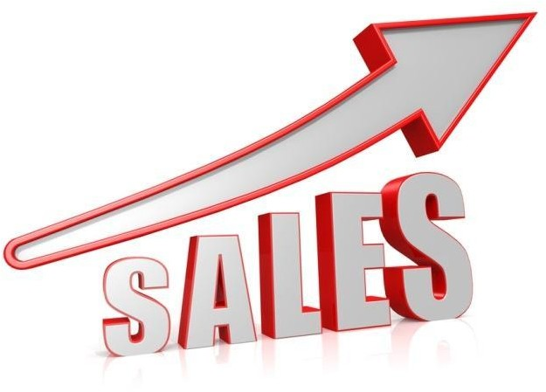

# The Importance of Sales Analysis:

Sales analysis is pivotal to an organization's success as it provides the foundation for informed decision-making. By examining sales data, businesses can identify patterns, trends, and potential opportunities, and gain insights into customer behavior. This data-driven approach enables organizations to protect their sales by understanding what is working and what needs improvement.

# Market Trends and Consumer Behavior:

Staying ahead in the market requires a deep understanding of market trends and consumer behavior. Protecting sales means adapting to the ever-changing market dynamics and ensuring that your products or services resonate with the evolving needs and preferences of your target audience.

# Competitive Analysis:

Protecting sales also entails a keen eye on the competition. Examining the strategies and performance of your competitors helps you identify your strengths and weaknesses. By comparing your sales data to that of your competitors, you can develop strategies to outperform them and safeguard your market share.

# Inventory Management:

Effective sales analysis involves not only understanding what sells but also managing inventory efficiently. Overstocking or understocking can lead to missed sales opportunities and financial losses. Inventory management is an integral part of protecting sales and ensuring optimal cash flow.

# Sales Force Performance:

The performance of your sales team is directly tied to your sales outcomes. Evaluating the effectiveness of your sales force through metrics like conversion rates, customer retention, and average deal size can uncover areas for improvement and ensure that your team is well-equipped to protect and grow sales.

# Pricing Strategies:

Price is a critical factor in the buying decision of customers. Sales analysis should include an evaluation of pricing strategies to determine their impact on sales volumes and revenue.

Adjusting pricing strategies based on data-driven insights can be a key element in protecting sales and profitability.

# Customer Relationship Management:

Nurturing and maintaining customer relationships is vital to protect and grow sales. A robust CRM system and analysis of customer data help in personalizing interactions, predicting customer needs, and ensuring customer loyalty.

# Digital Transformation and Technology:

In the digital age, leveraging technology is crucial for sales protection. This includes using data analytics tools, AI, and automation to gather and analyze data more effectively and identify opportunities or challenges in real-time.

# Compliance and Legal Considerations:

Sales analysis also encompasses compliance with legal and regulatory requirements. Ensuring that your sales practices align with industry and government standards is essential to protect your business from legal issues that could impact sales.

# DATASET :

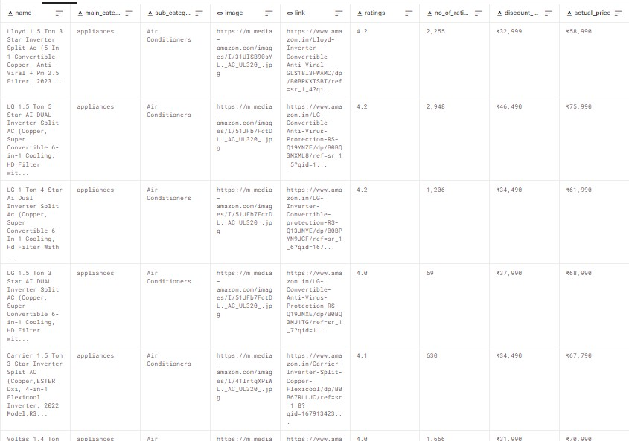

7*1267

# Design thinking process

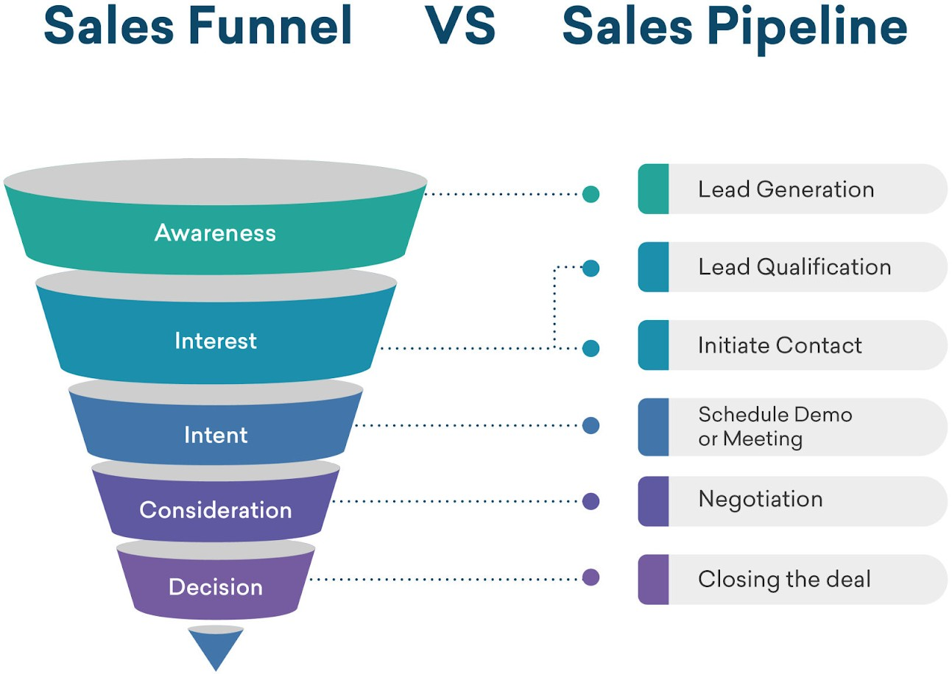

**Introduction:**

□ A sales analysis is the process of analyzing the sales revenue generated from a business within a period of time. It looks at various factors such as consumer demographics, products sold, time of sale, region and many more.

# Awareness for sales funnel:

* The first of the sales funnel stages is called the “awareness” level, because it's where people first become aware of your product or service. They may hear about you from your advertising, social media, even word of mouth.
* Awareness is the uppermost stage of the marketing funnel. Potential customers are drawn into this stage through marketing campaigns and consumer research and discovery.
* This updated sales funnel includes five stages:

Awareness: making buyers aware of your product as a solution to a specific pain point or problem. Consideration: buyers are considering your solution instead of competitors' solutions. Conversion: customer makes a final purchase decision.

* When someone becomes aware of your brand and turns into a potential customer. Interest: When a potential customer becomes interested in your brand's offerings. Desire: When a potential customer's interest becomes a desire for your brand's offerings.

□ the primary goals of marketing at the top of the funnel are awareness and lead generation.

# Interest for sales funnel:

* + Funnels are usually made of stainless steel, aluminium, glass, or plastic. The material used in its construction should be sturdy enough to withstand the weight of the substance being transferred, and it should not react with the substance.
  + A sales funnel helps you understand what potential customers are thinking and doing at each stage of the purchasing journey. These insights allow you to invest in the right marketing activities and channels, create the most relevant messaging during each stage and turn more prospects into paying customers.
  + Good sales funnels must have a customer-first approach. The best place to start when creating or optimizing your funnel is researching your prospects' recurring problems, questions, behaviors, and decision-making processes. Make sure you take the time to understand your audience or audiences
  + Action. The most important stage of the funnel — whether the prospect makes a purchase or not. If they don't buy from you now, that doesn't mean the deal is lost forever.

You can create nurture campaigns to make sure you stay on top of their mind for any future needs.

* + Marketing funnels are a useful tool to help you visualize the path customers take from first finding out about your brand to converting. Understanding them provides valuable insight into why some customers convert — and some

don't. Understanding how — and when — consumers interact with your brand is crucial.

* + The marketing funnel is based on the

Awareness-Interest-Desire-Action (AIDA) model, first developed in 1898 by E. St. Elmo Lewis, an advertising advocate.

* + If you aren't bringing in enough traffic, then your sales funnel has no chance to work. If you don't have enough visitors to your website or landing pages, then you won't have enough subscribers. If you don't have enough subscribers, then you won't have enough (or any) sales.

### INTENT:

Intent. At the Intent stage, your prospect makes the transition to the lower funnel. They're now interested in buying your product, but haven't made the purchase just yet. They might indicate their interest by taking a survey, watching a product demo, or placing an item in their shopping cart.

### Four sales funnel stages

* Step 1 — Define your audience's needs
* Step 2 — Create something valuable to offer
* Step 3 — Build a landing page
* Step 4 — Establish lead nurturing strategies

A sales funnel helps you understand what potential customers are thinking and doing at each stage of the purchasing journey. These insights allow you to invest in the right marketing activities and channels, create the most relevant messaging during each stage and turn more prospects into paying customers.

### The five stages of a sales funnel include:

1. Awareness. A sales funnel starts when someone first becomes aware of your company, product or service
2. Interest. Once a person becomes aware of your brand, the next funnel stage is to develop their interest in your business and learn about your offers
3. Desire
4. Action
5. Loyalty

### Consideration:

* + At the consideration stage, consumers interested in your business and its offerings are considering whether or not to buy. Depending on your business, this could include guides, webinars, reviews, white papers, case studies, comparison charts, and much more.
  + Representing the top of the funnel, this stage includes the most people. Consideration stage: The prospective buyer now wants to find and compare solutions to their problem, and they are looking for a solution that they can trust.

**□** What are consideration objectives? Consideration objectives sit in the middle of your marketing funnel.

Campaigns like these are for people who know who you are and want to learn more. Their purpose is to motivate your audience to take a low level, easy action, like visiting your website or joining your email list.

# Decision :

* . Third sales funnel stage. The customer is ready to buy and may consider several options before purchasing. They'll compare pricing, packages and other factors to find the best option. At this stage, you should make your best offer.
* Good sales funnels must have a customer-first approach.

*The best* place *to* start when *creating or optimizing your funnel is* researching your prospects' recurring problems, questions, behaviors, and decision-making processes. Make sure you take the time to understand *your audience or audiences*

### sales funnel stages:

* + Stage 1: Awareness
* Stage 2: Interest
* Stage 3: Decision
* Stage 4: Action
* Build a landing page
* Offer something of value
  + Start nurturing
  + Upsell

DEVELOPMENT PHASES :

Protecting sales analysis for different development phases is crucial to maintain confidentiality, competitive advantage, and sensitive information. Here are some steps and strategies to consider when safeguarding your sales analysis data during development phases:

### Data Classification:

* + Identify the various types of sales analysis data you handle, such as revenue figures, customer information, market trends, and internal strategies.
* Categorize the data into different levels of sensitivity, such as public, internal, confidential, and highly confidential**.**

### Access Control:

* + Implement strict access controls to limit who can view and modify sales analysis data.
  + Use role-based access controls to ensure that only authorized personnel can access specific data sets.
* Maintain an audit trail to monitor who accessed the data and when*.*

### Encryption:

Encrypt sales analysis data both in transit and at rest. This ensures that even if unauthorized access occurs, the data remains unreadable without the proper encryption keys.

### Secure Storage:

* + Store sensitive sales analysis data on secure servers and databases, and regularly update security configurations.
  + Use secure cloud storage solutions with robust security measures and data protection protocols.

### Data Loss Prevention (DLP) Tools:

* + Employ DLP software and tools to prevent unauthorized data transfers or leakage.
  + Set up rules and policies that monitor and block the sharing of sensitive sales analysis data through various communication channels.

### Secure Communication:

* + Use secure communication protocols for sharing sensitive sales analysis data within and outside your organization.
  + Encrypt email communications, use secure file-sharing platforms, and enforce strong authentication methods.

### Employee Training:

Conduct regular training and awareness programs to educate employees about the importance of data security and their role in protecting sales analysis data.

# Describe the analysis objectivies :

Product sales analysis is a crucial process for businesses that helps them gain insights into their sales performance, customer behavior, and market trends. The analysis objectives can vary depending on the specific goals of the business, but some common objectives include.

1. **Revenue Growth** : The primary objective of sales analysis is often to assess revenue growth. Businesses aim to understand how their sales have evolved over time, identify growth opportunities, and set targets for increasing revenue.
2. **Market Understanding** : Analyzing product sales can provide insights into the overall market. Businesses may want to understand market trends, customer preferences, and competitive dynamics to make informed decisions.
3. **Performance Evaluation :** Sales analysis allows businesses to evaluate the performance of individual products or product categories. This helps in identifying top-performing and underperforming products.
4. **Customer Segmentation :** To improve marketing and sales strategies, businesses often aim to segment their customers. Sales analysis can help identify customer groups with distinct buying behaviors.
5. **Inventory Management :** Effective sales analysis helps in managing inventory levels more efficiently. It ensures that products are available when needed but not overstocked, which can tie up capital.
6. **Pricing Strategy** : Determining the right pricing strategy is crucial. Analysis can help assess the impact of different pricing strategies on sales volume and revenue.
7. **Sales Channel Assessment** : Understanding how products perform in different sales channels (e.g., online, in-store, through distributors) is essential for optimizing the distribution strategy.
8. **Seasonal Patterns** : Many businesses have products with seasonal demand. The analysis can reveal these patterns and help plan for season-specific marketing and inventory adjustments.
9. **Customer Lifetime Value** : To maximize the value of each customer, it's important to understand their long-term value. Sales analysis can help assess this and guide customer retention efforts.
10. **Forecasting** : Sales analysis can be used to develop forecasts and predictions about future sales. This can inform production, inventory, and staffing decisions.

# Data collection Process :

Overview of the process:

Product sales analysis is a crucial aspect of business operations that involves examining the performance of products or services within a company. The analysis provides valuable insights into sales trends, customer behavior, and helps businesses make informed decisions to improve their sales strategies.

### Data Collection:

- Gather relevant data: Collect data from various sources, such as point-of-sale systems, e-commerce platforms, CRM software, and any other relevant data repositories. This data can include sales transactions, customer information, product details, and pricing information.

# Data Encryption :

**-** Use encryption protocols to secure data in transit. Ensure that data is encrypted when it's being transferred from one system to another, such as from the point of sale (POS) system to your data storage.

# Access Control :

Limit access to the data to authorized personnel only. Implement role-based access control, ensuring that employees can only access the data they need to perform their jobs.

# Data Masking :

- If you're sharing data with third-party vendors or partners, consider using data masking techniques to anonymize or pseudonymize sensitive information. This way, personal customer information is protected.

# Regular Backups :

**-** Regularly back up your sales data to prevent data loss due to hardware failure or other unforeseen events. These backups should be securely stored and regularly tested for recovery.

# Data visualization using IBM Cognos :

Protecting sales analysis data for data visualization using IBM Cognos involves several steps to ensure that sensitive information is secure and only accessible to authorized users. Here are some best practices for securing your sales analysis data in IBM Cognos

import numpy as np import pandas as pd import os

for dirname, _, filenames **in** os.walk('/kaggle/input'): for filename **in** filenames: print(os.path.join(dirname, filename))

### INPUT :

import pandas as pd import numpy as np import seaborn as sns

import matplotlib.pyplot as plt pd.options.display.max_columns=50 sns.set(style="darkgrid")

### IMPORTING DATA:

df=pd.read_csv("/kaggle/input/product-sales-data/statsfinal.csv") df.head(5)

# OUTPUT:

|  |  |  |  |  |  |  |  |  |  |  |
| --- | --- | --- | --- | --- | --- | --- | --- | --- | --- | --- |
|  | Unnamed:  0 | Date | Q-P  1 | Q-P  2 | Q-P  3 | Q-P  4 | S-P1 | S-P2 | S-P3 | S-P4 |
| 0 | 0 | 13-06-2  010 | 5422 | 3725 | 576 | 907 | 17187.74 | 23616.50 | 3121.92 | 6466.91 |
| 1 | 1 | 14-06-2  010 | 7047 | 779 | 3578 | 1574 | 22338.99 | 4938.86 | 19392.76 | 11222.62 |
| 2 | 2 | 15-06-2  010 | 1572 | 2082 | 595 | 1145 | 4983.24 | 13199.88 | 3224.90 | 8163.85 |
| 3 | 3 | 16-06-2  010 | 5657 | 2399 | 3140 | 1672 | 17932.69 | 15209.66 | 17018.80 | 11921.36 |
| 4 | 4 | 17-06-2  010 | 3668 | 3207 | 2184 | 708 | 11627.56 | 20332.38 | 11837.28 | 5048.04 |

**INPUT :**

*#* Create a figure and axis def month_plot():

fig, ax = plt.subplots()

# Plot the sales data for each product by month

data_reduced.groupby('Month')[['Q-P1', 'Q-P2', 'Q-P3',

'Q-P4']].sum().plot(ax=ax)

# Set the x-axis limits to only show up to December

ax.set_xlim(left=0, right=13)

# Set the axis labels and title

ax.set_xlabel('Month') ax.set_ylabel('Total unit sales')

ax.set_title('Trend in sales of all four products by month') # Show the plot

plt.show()

month_plot()

# OUTPUT:

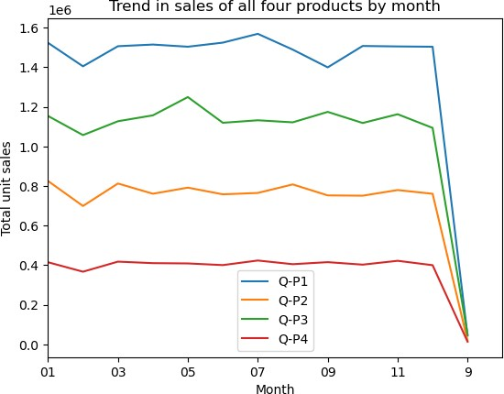

### INPUT :

plot_bar_chart(_31_months, ['Q-P1', 'Q-P2', 'Q-P3', 'Q-P4'], 'Average Units', 'each Month, for 31st', 'mean')

### OUTPUT:

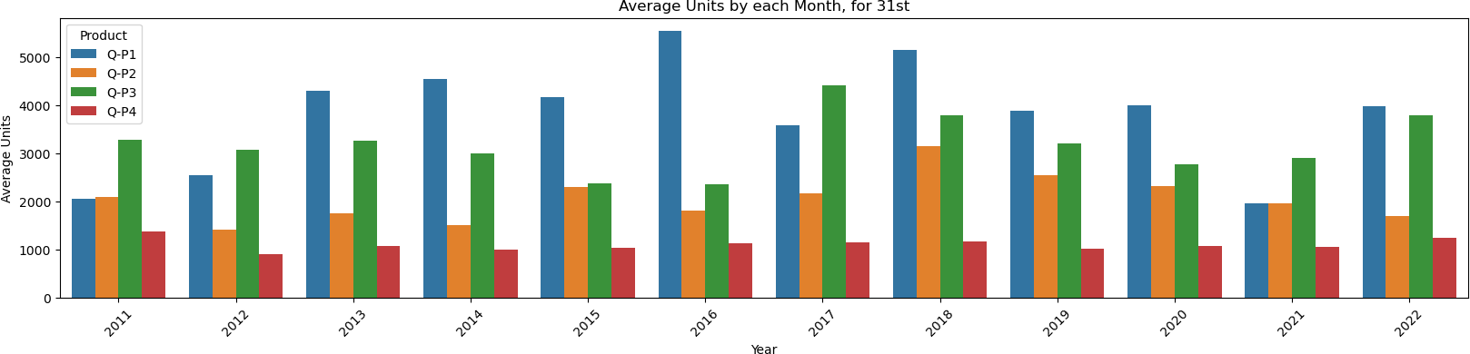

**INPUT :**

Plot_ bar_ chart (_31_months, ['S-P1', 'S-P2', 'S-P3', 'S-P4'], 'Average Revenue', 'each Month, for 31st', c 'mean')

**OUTPUT :**

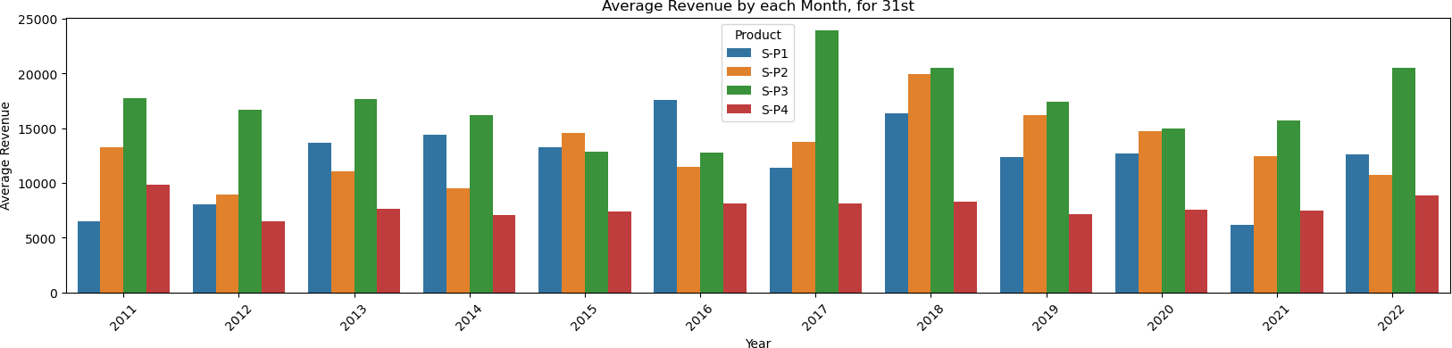

# Derived actionable insights :

Protecting sales analysis for deriving actionable insights is crucial to ensure that sensitive business information is safeguarded and that the insights are used effectively for decision-making. Here are some best practices to protect your sales analysis and the derived actionable insights:

1. Access Control :

- Implement strict access controls and user authentication mechanisms to restrict access to sales analysis data and actionable insights. Only authorized personnel should have access to this information.

1. Role-Based Access :

- Use role-based access control to ensure that individuals only have access to the specific insights and data relevant to their roles and responsibilities.

1. Data Encryption :

- Encrypt the data both in transit and at rest. Use encryption protocols to secure data as it is transmitted and ensure data storage is encrypted to protect against unauthorized access.

1. Data Anonymization :

If possible, anonymize or de-identify data used for analysis to protect the privacy of individuals or organizations involved in

the sales data. This is especially important if your analysis includes sensitive customer information.

1. Data Masking :

Implement data masking or obfuscation techniques to hide sensitive data within the insights shared with users who do not need access to that information.

# Explain how the insights from the analysis can guide inventory management :

Analyzing product sales data is a crucial aspect of effective inventory management. The insights gained from such analysis can significantly influence and guide inventory management in the following ways

1. **Demand Forecasting:** By examining historical sales data, businesses can identify sales trends and patterns. This information helps in making accurate demand forecasts for each product, which, in turn, allows for better inventory planning. Maintaining optimal inventory levels ensures that you neither overstock nor run out of stock, reducing carrying costs and ensuring products are readily available to meet customer demand.
2. **Seasonal and Cyclical Trends:** Sales data analysis can reveal seasonal or cyclical variations in product demand. Certain products may experience surges in sales during specific times of the year or in response to market events. By recognizing these patterns, you can adjust your inventory levels accordingly, ordering more stock in anticipation of peak demand and reducing it during slower periods. This minimizes the risk of overstocking and understock

# Marketing Strategies :

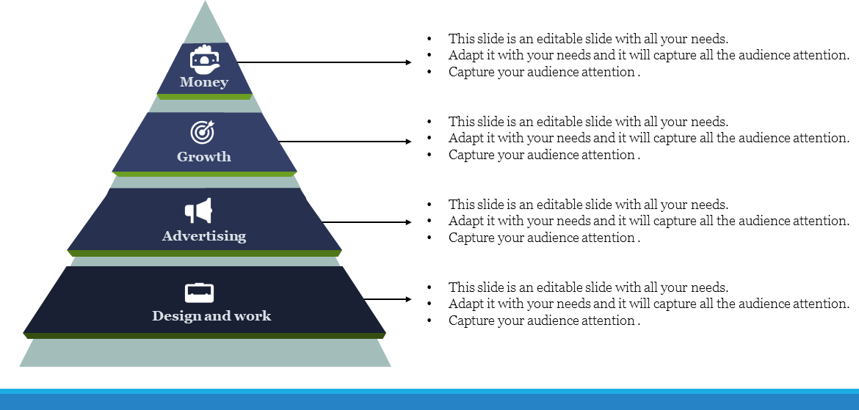

**Advantages :**

1. **Informed Decision-Making:** Sales analysis provides valuable insights into what products are selling well and which ones are underperforming. This information helps businesses make informed decisions about inventory management, product development, pricing strategies, and marketing efforts.
2. **Revenue Maximization:** By identifying top-selling products and focusing on their promotion, pricing, and availability, businesses can maximize their revenue. This can lead to increased profitability and sustainable growth.
3. **Inventory Management**: Analyzing product sales data helps in managing inventory efficiently. Businesses can reduce carrying costs, minimize overstocking or understocking issues, and maintain optimal stock levels to meet customer demand.
4. **Customer Segmentation:** Sales data analysis allows businesses to understand their customers better. They can segment their customer base based on purchasing behaviors, preferences, and demographics. This information can be used to tailor marketing strategies and improve customer satisfaction.
5. **Seasonal Trends:** Recognizing seasonal sales trends enables businesses to prepare for peak and off-peak periods. This helps in allocating resources effectively, adjusting marketing strategies, and optimizing stock levels to match demand fluctuations.



Conclusion:

Analyzing product sales data can provide valuable insights for businesses to make informed decisions and drive growth. In conclusion, the analysis of product sales data can yield several key takeaways:

Performance Evaluation: By examining sales data, businesses can assess the performance of their products over a specific time frame. This evaluation helps in identifying best-sellers,

slow-moving items, and those that may need repositioning or discontinuation.

Market Trends: Product sales analysis can reveal market trends, including seasonal fluctuations, changing customer preferences, and emerging consumer demands. This information is essential for adapting to the dynamic market environment.

as purchase patterns, buying frequency, and preferred payment methods. Understanding customer behavior is crucial for creating targeted marketing campaigns and improving customer experience

Pricing Strategy: Analyzing product sales data allows businesses to assess the impact of pricing strategies on sales volume and revenue. It can help optimizing pricing to maximize profitability without sacrificing market share.

Inventory Management: Sales data analysis aids in better inventory management by identifying products that are overstocked or under stocked. This, in turn, can reduce holding costs and prevent stock outs or overages.